APPENDIX B: USER MANUAL

Users’ Manual

PUP Medical Clinic

Patient logs and inventory system

October 2016

1.0) GENERAL INFORMATION
System Overview
Organization of the manual
2.0) SYSTEM SUMMARY
System Configuration
User Access Levels
3.0) GETTING STARTED
Installation and Logging-in
System Menu
4.0) USING THE System
Main menu
Medicine Form
Add Medicine Form
Edit Medicine Form
Supply Form
Add Supply Form
Edit Supply Form
Equipment Form
Add Equipment Form
Edit Equipment Form
Student Records Form
Patient Registration Form
Edit Patient Form
Faculty Records Form
Admin Records Form
Supplier Form
Add Supplier Form
Edit Supplier Form
Manufacturer form
Add Manufacturer Form
Edit Manufacturer Form
Branches Form
Add Branch Form
Edit Branch Form
Colleges and Courses Form
Add College Form
Edit College Form
Add Course Form
Edit Course Form
Departments Form
Add Department Form
Edit Department Form
Item Inventory Form
Receive Inventory Form
Receive Items Form
Item distribution Form
Add Item to Distribute Form
Patient Logs Form
Add Patient Log
Stock Card (Report)
Daily Treatment Record(Report)
Receive Item (Report)
Item Distribution (Report)
List of Items (Report)
Notifications Form

- General Information

System Overview
The Patient Logs and Inventory System is a system used to improve the way of tracking, sorting, monitoring and retrieving of information that would be precise, accurate and well organized.

Organization of the manual
The user’s manual consists of four sections: General Information, System Summary, Getting Started and Using the System.

General Information section explains in general terms the system and the purpose for which it is intended.

System Summary section provides a general overview of the system. The summary outlines the uses of the system’s hardware and software requirements, system’s configuration, user access levels and system’s behavior in case of any contingencies.

Getting Started section briefly presents the system menu.
Using The System section provides a detailed description of system functions.

2.0 System Summary

System Configuration
The Case Management Information System operates on computers with Windows operating system.

User Access Levels
Admin(Director) – the admin can access all module in the system.
Staff (clinic personnel)- the Staff can access all modules but cannot Edit and delete any data.

3.0 Getting Started

Installation and Logging-in
Double click the ‘PUPiMed_Setup.exe to install the system
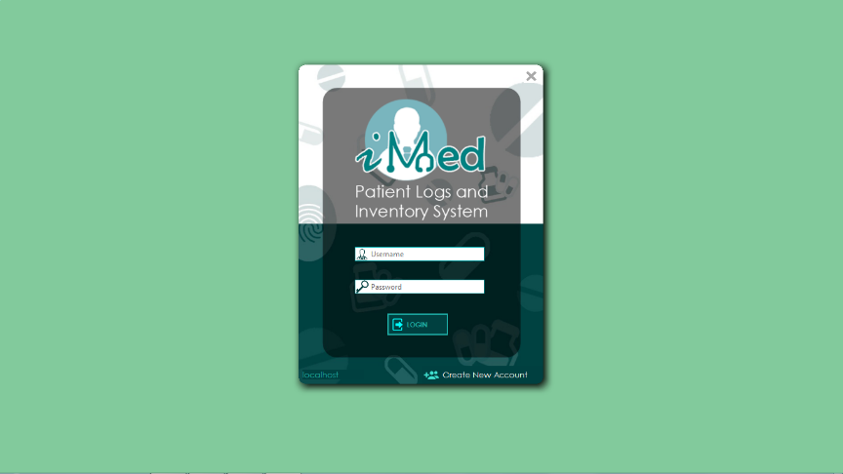Figure 1.
To log in, enter the requested information on the log in form (Figure 1).

System Menu
Figure 2
The main menu of the Patient Logs and Inventory System (Figure 2) consist of 8 buttons; Maintenance. Item Inventory, Receive Inventory, Item Distribution, Patient Logs, Reports, Notification and Log out.

4.0 Using the System

Main Menu
Figure 2 Main Menu Form
The main menu of the Patient Logs and Inventory System (Figure 2) consist of 8 buttons; Maintenance. Item Inventory, Receive Inventory, Item Distribution, Patient Logs, Reports, Notification and Log out.
Medicine Form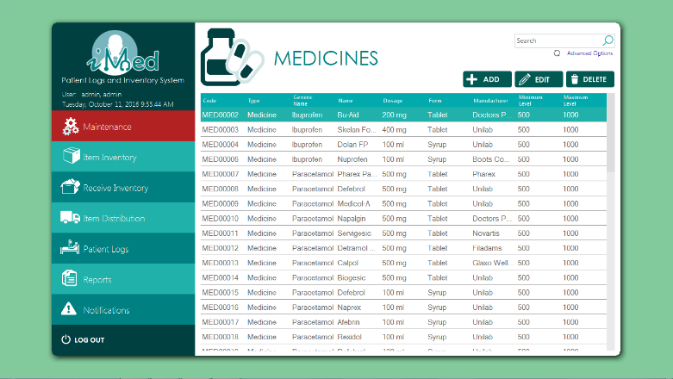Figure 3 Medicine form
The Medicine Form (figure 3) shows all the details of the medicines. It also consists of thee buttons; Add, edit and delete.
Add Medicine Form
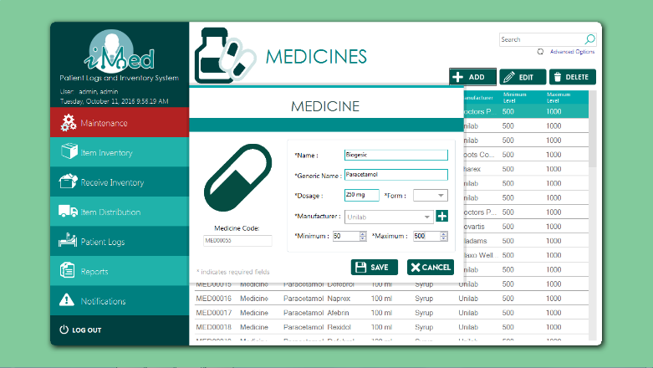Figure 4 Add Medicine Form
The Add Medicine Form (figure 4) lets the user add the information of a new medicine.
Edit Medicine Form
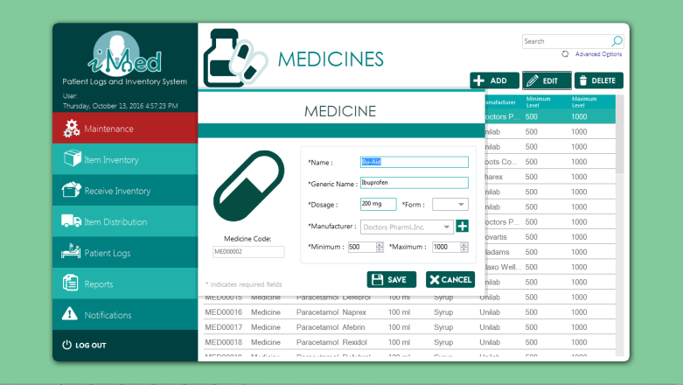
Figure 5 Edit Medicine Form
The Edit Medicine Form(Figure 5) lets the Admin to Edit the Details of the selected Medicine. Only the Admin(director) can Edit.
Supply Form
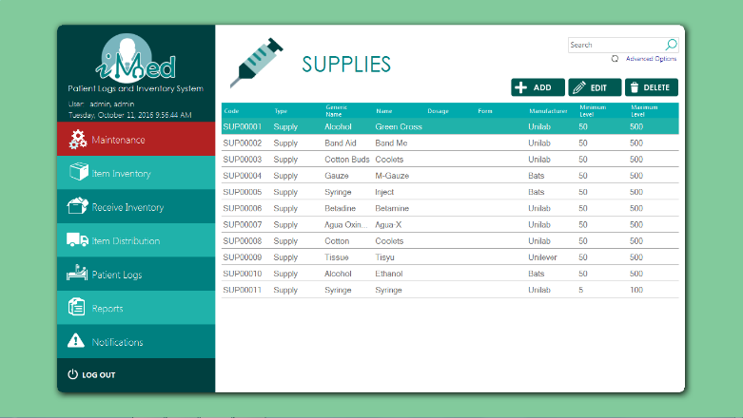Figure 6 Supply Form
The Supply Form (figure 6) displays all the details of the Supplies. It also consists of thee buttons; Add, edit and delete.
Add Supply Form
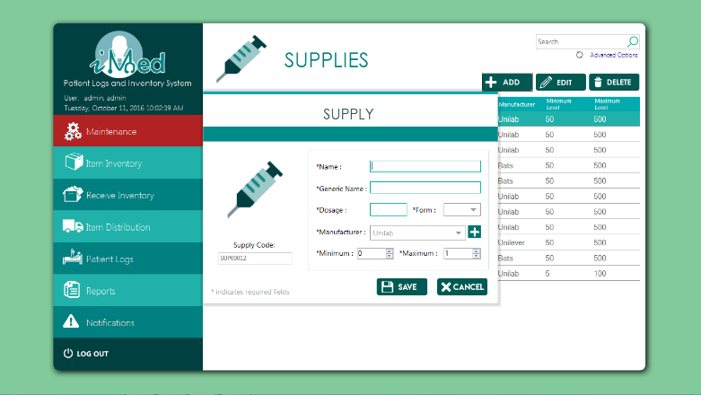Figure 7 Add supply Form
The Add Supply Form (figure 7) lets the user add the information of a new supply.

Edit Supply Form
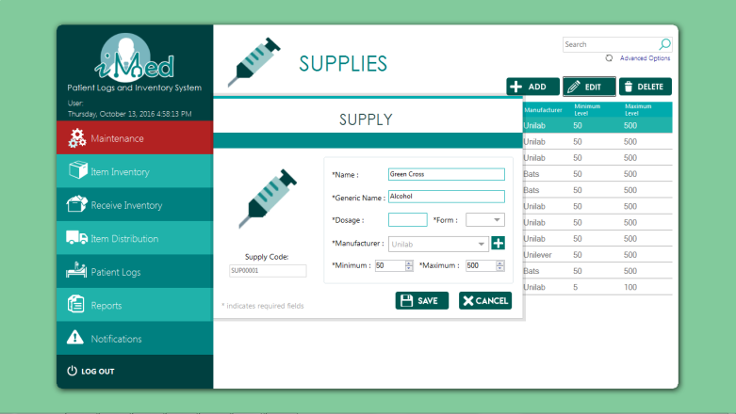
Figure 8 Edit Supply Form
The Edit Supply Form(Figure 8) lets the Admin to Edit the Details of the selected Supply. Only the Admin(director) can Edit.
Equipment Form
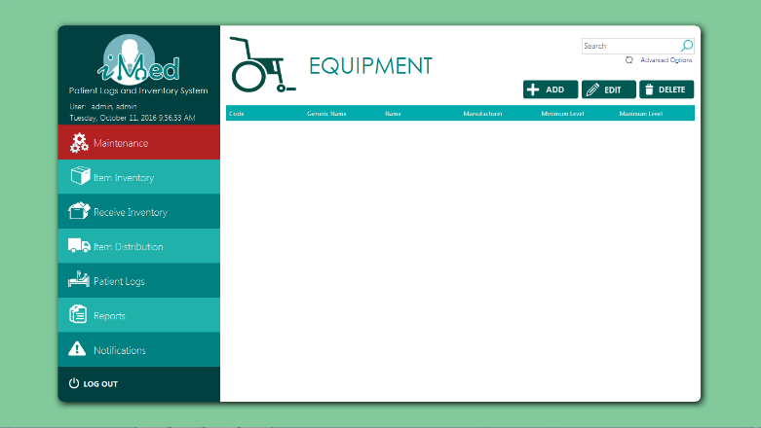Figure 9 Equipment Form
The Equipment Form (Figure 9) displays all the details of the Equipment. It also consists of thee buttons; Add, edit and delete.
Add Equipment Form
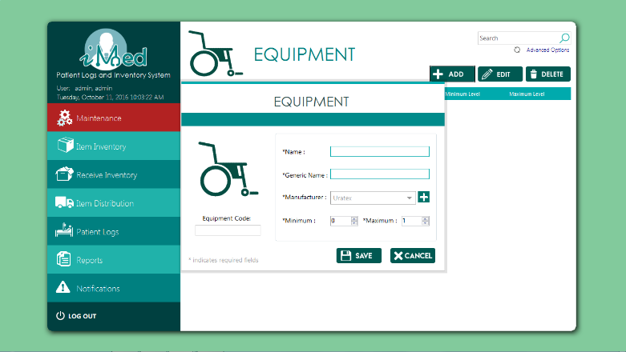Figure 10 Add Equipment Form
The add Equipment From (figure 10) lets the user add the Information of a new Equipment.
Edit Equipment Form
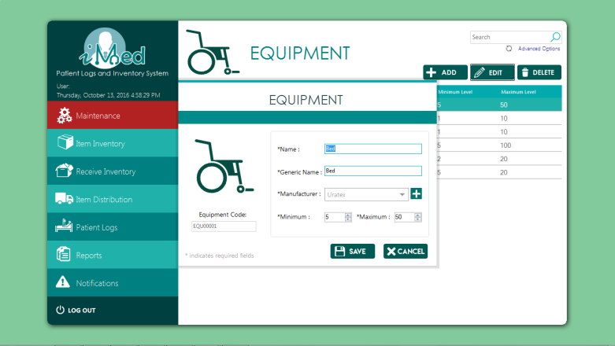
Figure 11 Edit Equipment Form
The Edit Equipment Form (Figure 11) lets the Admin to Edit the Details of the selected Equipment. Only the Admin (director) can Edit.
Student Records Form
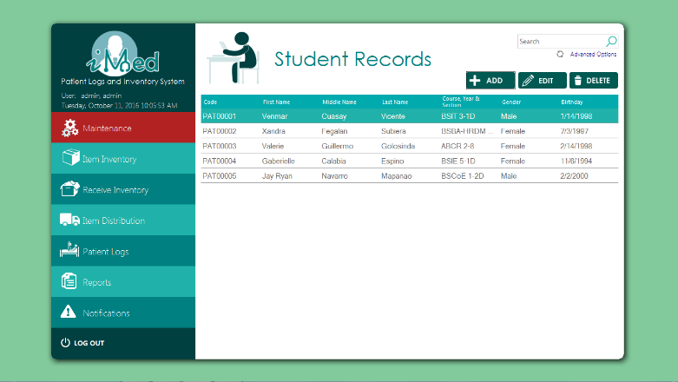Figure 12 Student Records From
The Student Records From (Figure 12) Displays the Details of the Student Patients that came to the Clinic. It also consists of thee buttons; Add, edit and delete.

Patient Registration From
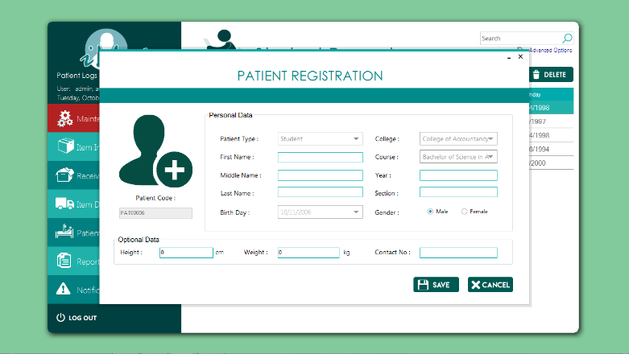Figure 13 Patient Registration Form
The Patient Registration Form (Figure 13) lets the user add the information of a new Patient.
Edit Patient Form
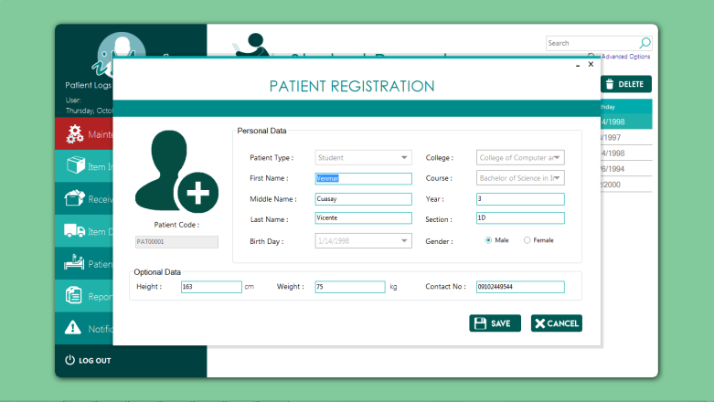
Figure 14 Edit Patient Form
The Edit Patient Form (Figure 14) lets the Admin to Edit the Details of the selected Patient. Only the Admin(director) can Edit.
Faculty Records From
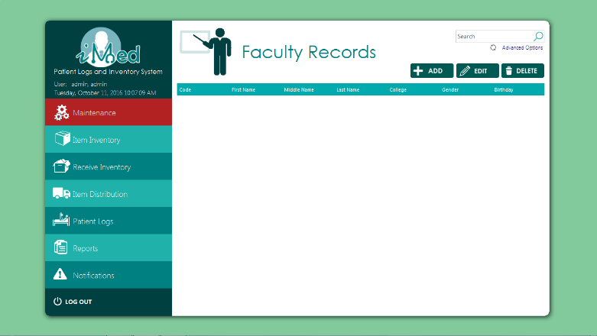Figure 15 Faculty Records Form
The faculty Records Form (Figure 15) Displays the Details of the Faculty Patients that came to the Clinic. It also consists of three buttons; Add, Edit and Delete.
Admin Records Form
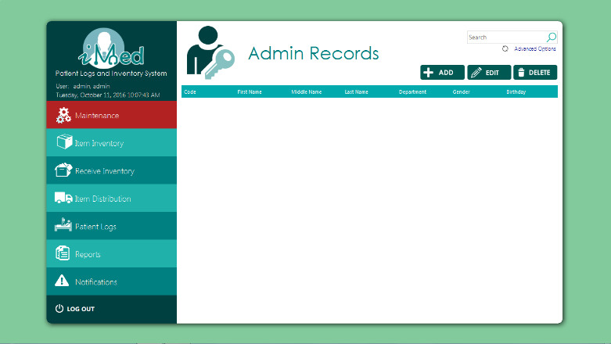Figure 16 Admin Records Form
The Admin Records Form (Figure 16) Displays the Details of the Admin Patients that came to the Clinic. It also consists of three buttons; Add, Edit and Delete.
Supplier form
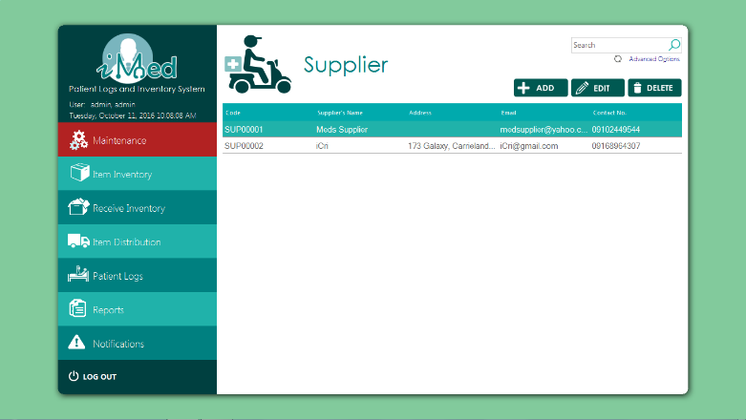Figure 17 Supplier From
The supplier from (figure 17) displays the details of the Suppliers. It also consists of three buttons; Add, Edit and Delete.
Add Supplier Form
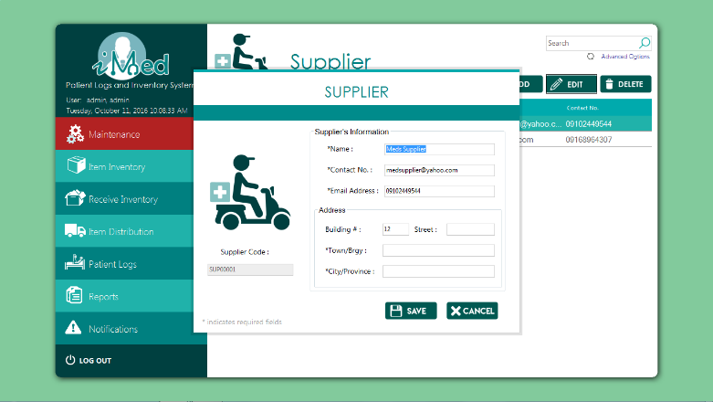Figure 18 Add Supplier Form
The Add Supplier Form (figure 18) lets the user add the information of a new Supplier.
Edit Supplier Form
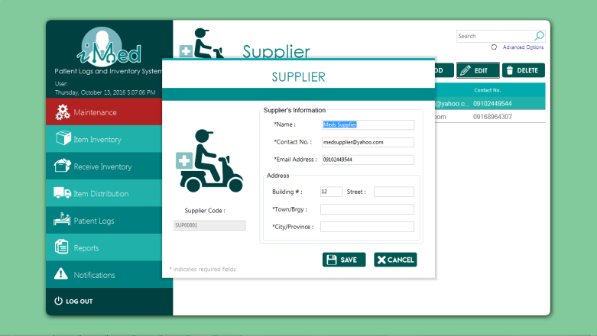
Figure 19 Edit Patient Form
The Edit Supplier Form (Figure 19) lets the Admin to Edit the Details of the selected Supplier. Only the Admin(director) can Edit.
Manufacturer Form
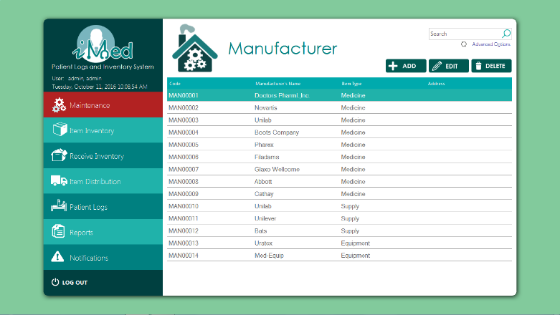Figure 20 Manufacturer Form
The Manufacturer Form (figure 20) Displays the details of the Manufacturer. It also consists of three buttons; Add, Edit and Delete.
Add Manufacturer Form
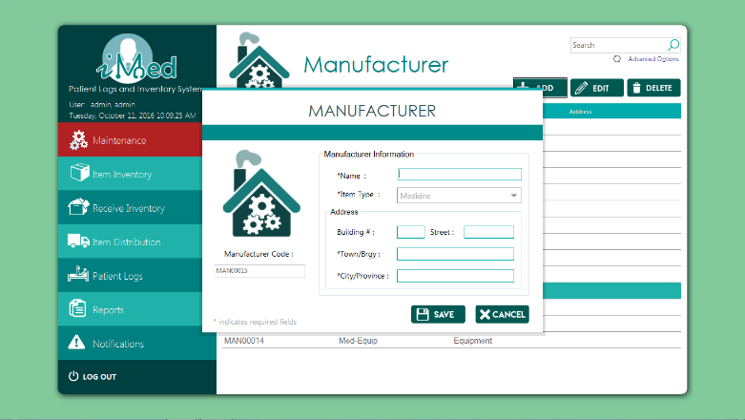Figure 21 Add Manufacturer Form
The Add Manufacturer Form (Figure 21) lets the user add the information of the new Manufacturer.

Edit Manufacturer Form
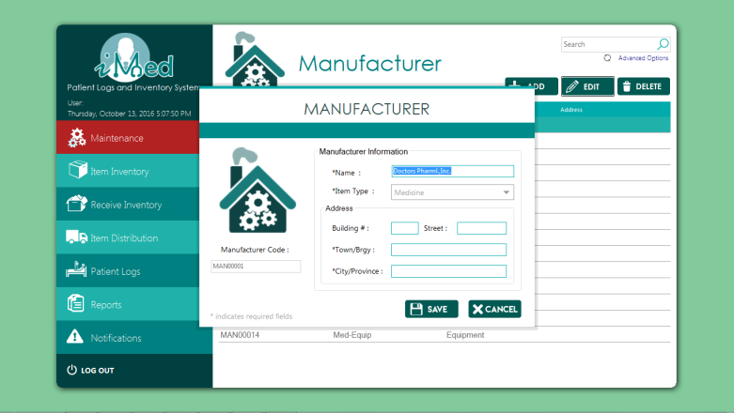
Figure 22 Edit Manufacturer Form
The Edit Manufacturer Form (Figure 22) lets the Admin to Edit the Details of the selected Manufacturer. Only the Admin(director) can Edit.
Branches Form
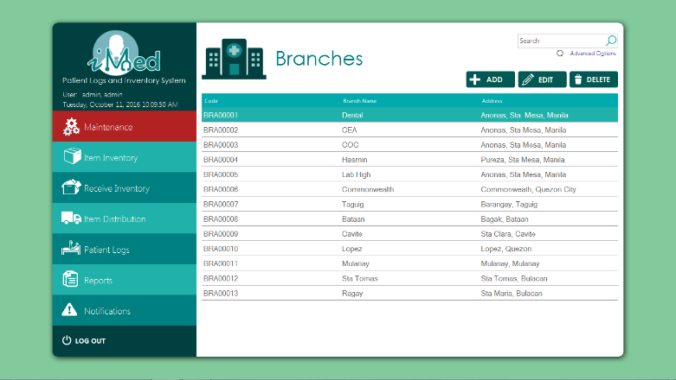Figure 23 Branches Form
The Branches Form (Figure 23) Displays the details of the Branches. It also consists of three buttons; Add, Edit and Delete.
Add Branch Form
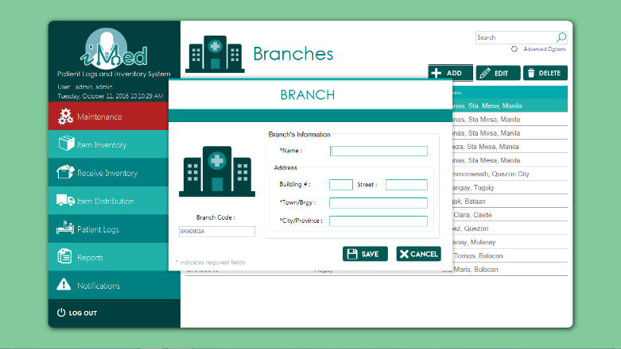Figure 24 Add Branch Form
The Add Branch Form (Figure 24) lets the user add the information of the new Branch.
Edit Branch Form
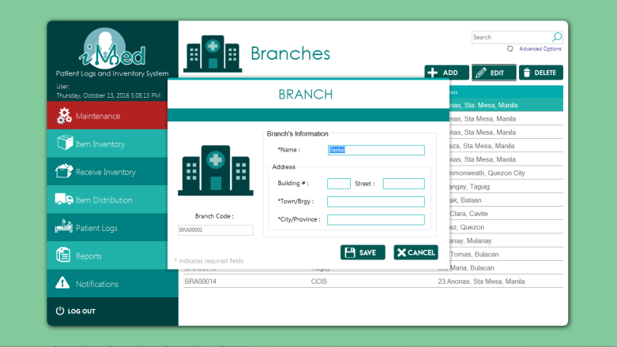
Figure 25 Edit Branch Form
The Edit Branches Form (Figure 25) lets the Admin to Edit the Details of the selected Branch. Only the Admin(director) can Edit.

Colleges and Courses Form
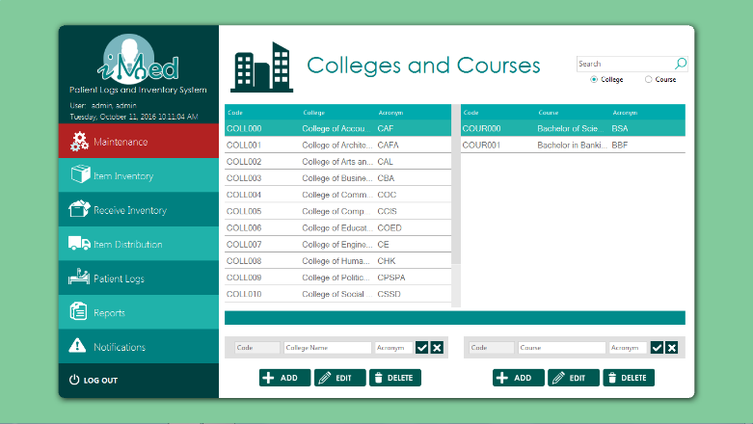Figure 26 Colleges and courses Form
The College and Courses Form (Figure 26) Displays the Details of the Colleges and Courses. It also consists of six buttons; Add College, Edit College, Delete College, Add Course, Edit Course, Delete Course.
Add College Form
Figure 27 Add College Form
The Add College Form (Figure 27) lets the user add the information of the new college.

Edit College Form
Figure 28 Edit College Form
The Edit College Form (Figure 28) lets the Admin to Edit the Details of the selected College. Only the Admin(director) can Edit.

Add Course Form
Figure 29 Add Course Form
The Add Course Form (Figure 29) lets the user add the information of the new course.

Edit Course Form
Figure 30 Edit Course Form
The Edit Course Form (Figure 30) lets the Admin Edit the Details of the selected course. Only the Admin (director) can Edit.
Departments Form
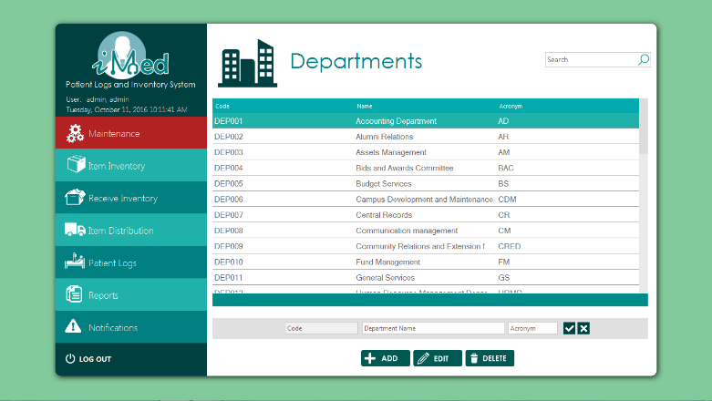Figure 31 Departments Form
The Departments form (Figure 31) Displays the Details of the Departments. It also consists of three buttons; Add, Edit and Delete.

Add Department Form
Figure 32 Add Department Form
The Add Department Form (Figure 32) lets the user add the information of the new Department.

Edit Department Form
Figure 33 Edit Department Form
The Edit Department Form (Figure 33) lets the Admin Edit the Details of the selected Department. Only the Admin (director) can Edit.

Item Inventory Form
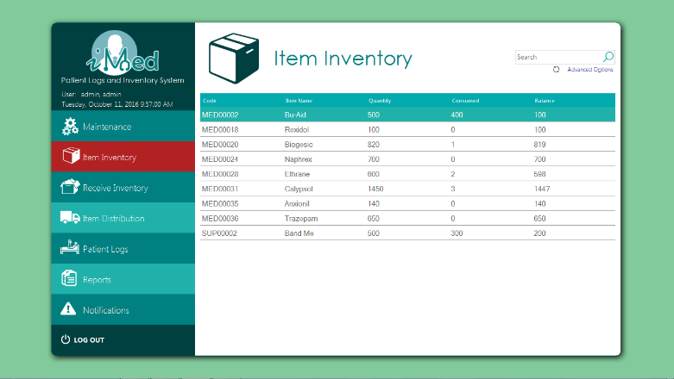Figure 34 Item Inventory Form
The Item Inventory Form (Figure 34) Displays the list of items that is in the Inventory.
Receive Inventory Form
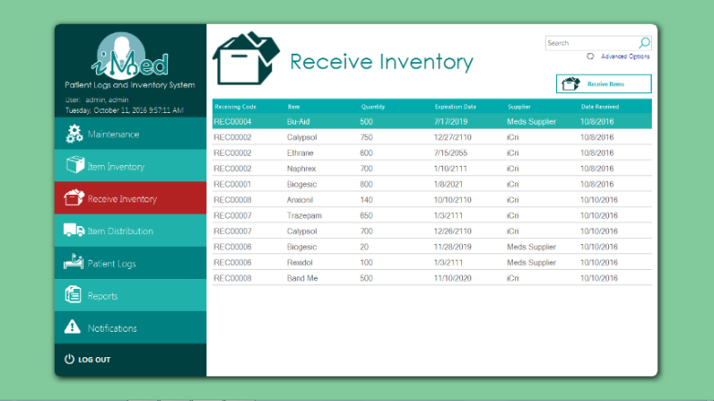Figure 35 Receive Inventory Form
The Receive Inventory Form (Figure 35) Displays the Details of the Received Items. It also has a Receive Item button.
Receive Items Form
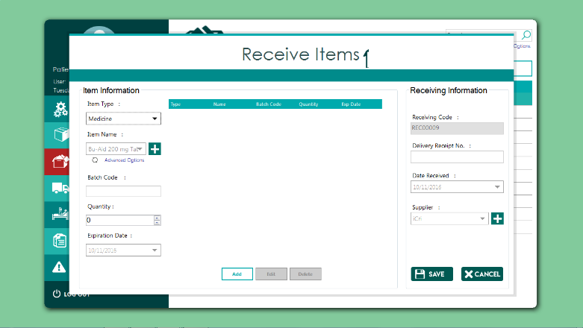Figure 36 Receive Item Form
The Receive Item Form (Figure 36) Lets the user add the information of the Items that was received.
Item Distribution From
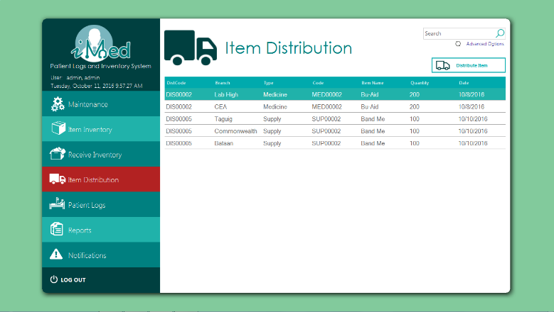Figure 37 Item Distribution Form
The Item Distribution Form(Figure 37) Displays the Items that were Distributed to other branches. It also has a Distribute Item button.

Add Item to Distribute Form
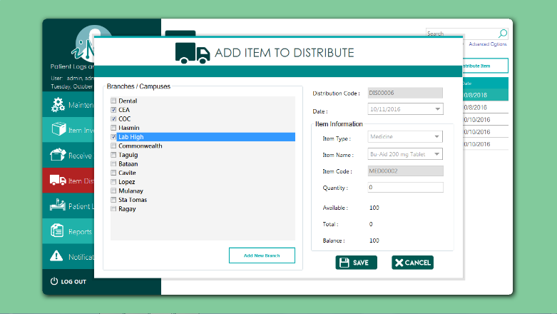Figure 38 Add Item to distribute Form
The Add Item to Distribute Form (Figure 38) lets the user add the Information of the Items to be Distributed.
Patient Logs Form
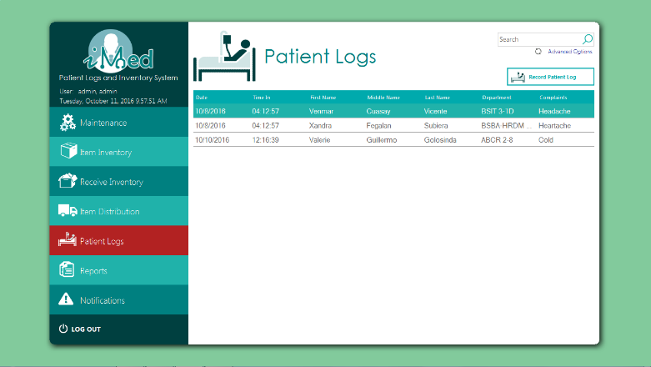Figure 39 Patient Logs Form
The Patient Logs Form (Figure 39) Displays the details of the Patients visit to the clinic. It also has a Record patient log button.

Add Patient Log Form
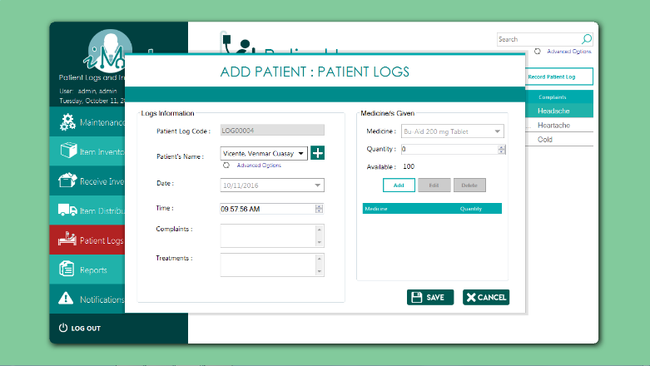Figure 40 Add Patient Log
The Add Patient Log Form (Figure 40) lets the user add the information of anew patient log.
Stock Card From (Report)
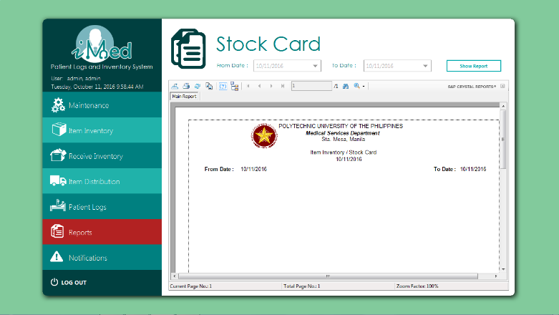Figure 41 Stock Card Form
The Stock Card From (Figure 41) Generates a Stock Card Report.

Daily Treatment Record Form (Record)
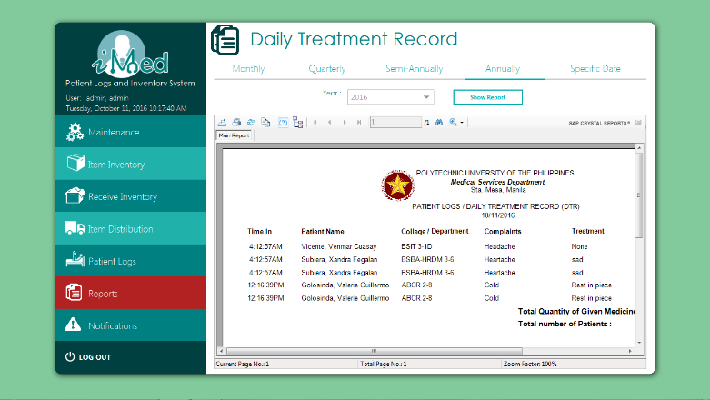Figure 42 Daily Treatment Record Form
The Daily Treatment Record Form (Figure 42) Generates a Daily Treatment Record.
Receive Item Form (Report)
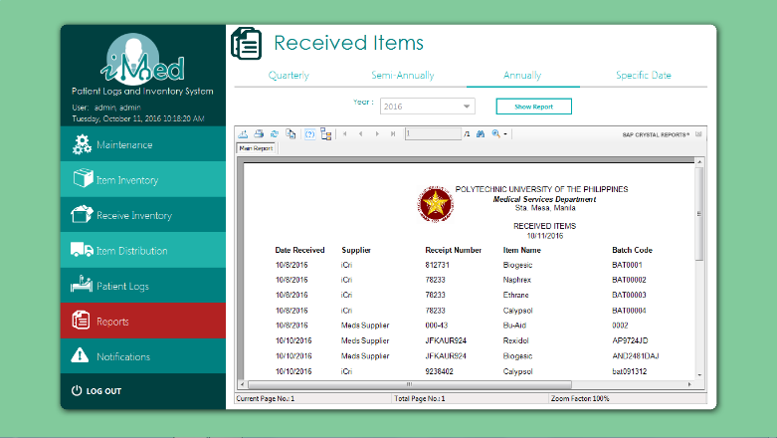Figure 43 Receive Item Form (Report)
The Receive Item Form (Figure 43) Generates a Receive Item Report.

Item Distribution (Report)
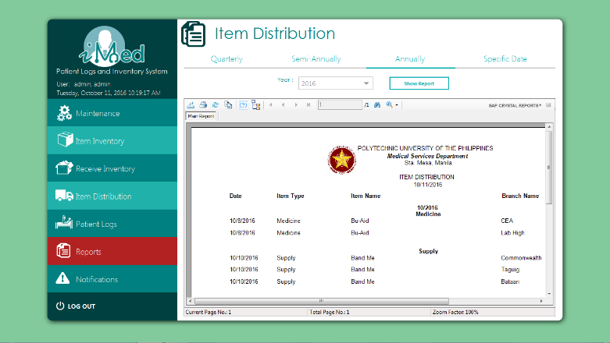Figure 44 Item Distribution (Report)
The Item Distribution Report (Figure 44) Generates an Item Distribution Report.
List of Items (Report)
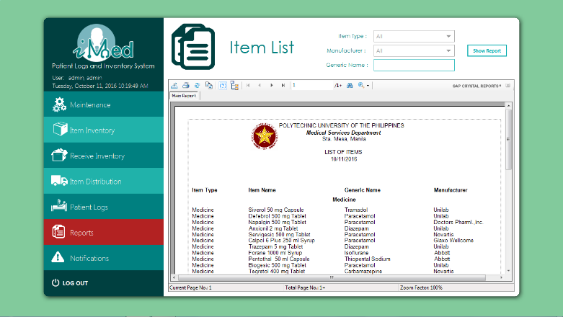Figure 45 List of Items
The List of Items (Figure 45) Generates a list of item Report.

Notifications Form
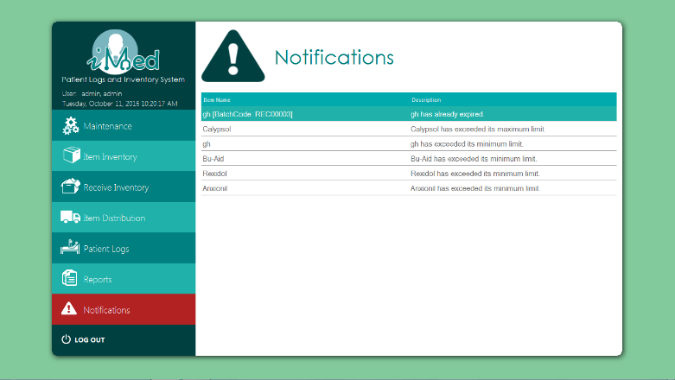Figure 46 Notifications
The Notification Form (Figure 46) Displays the list of notification. A notification will be made whenever an Item is close to its Expiration date and when an item reaches its minimum stock or exceeds its maximum stock.

